Capacitive Grip Force Sensor For A Robot Arm

Peiris M.T.H
Department of Electrical and Electronic Engineering
University of Peradeniya
Sri Lanka
e19276@eng.pdn.ac.lk
Ratnayake R.M.A.M.B
Department of Electrical and Electronic Engineering
University of Peradeniya
Sri Lanka
e19328@eng.pdn.ac.lk
Wijenayake W.M.B.S.K.
Department of Electrical and Electronic Engineering
University of Peradeniya
Sri Lanka
e19445@eng.pdn.ac.lk

Abstract—This project is designed to develop a sensor to measure the grip force when an object is held by a robot arm. It also measures any force given to the sensor within the designed range. When a force is applied to the sensor consisting of a capacitor, it changes the distance between the parallel plates of the capacitor and hence changes its capacitance. Then the sensor reads the corresponding change in capacitance. Since the sensor simply contains only a capacitor it is simple in technology. It can measure a range of force from 5N to 50N.
Keywords—capacitance, force, sensor

Introduction
This project was conducted to invent a sensor to measure the grip force exerted by a robot arm.
Initially, research was done to find out the methods used to build grip force measuring sensors. As a result, 5 methods were taken into consideration namely, strain gauge pressure sensors, Capacitive grip force sensors, piezoelectric transducers, EFPI-based pressure sensors, and piezoresistive transducers.
Strain gauge pressure sensors are unable to provide measurements for low-range forces. In addition, they are creep due to adhesive agents [1]. On the other hand, piezoelectric transducers operate with a small electrical charge. Thus, a high piezoelectric cable is needed [2]. Apart from that, in the EFPI-based pressure sensor, different methods are used to measure different ranges of pressure [3]. And, piezoresistive transducers only can measure dynamic pressures [4]. Considering the above facts and the resources we have, we decided to use the capacitive method for the sensor. In addition, the main requirements of the project i.e., high accuracy and sensitivity was achievable with the capacitive method.
In the sensor, there are one or more dielectric material layers surrounded with an Aluminum foil resulting in a capacitance between two sides of the aluminum foil. As a force is acting, the distance between two parallel plates of the capacitor is changed. It yields a change in capacitance. That change in the capacitance is taken to measure the grip force. The sensor is capable of measuring forces between 5N and 50N.
In the industry, the sensor can be installed into a robot arm. It will measure the grip force using the change in distance of two parallel plates due to the force. The range of the sensor can be adjusted depending on the application by changing the area of the sensor. And more than one layer of dielectric material can be used to build parallelly connected capacitors which help to extend the range of the sensor.

Initial Specifications

Measurement Quality
This sensor is applicable to any robot arm with different shapes and capable of measuring point and distributed loads with a reasonable response rate.

Range
The basic design is to measure grip forces in the range of 1N-50N. However, it can be customized to measure more than 50N by changing the area of the sensor.

Resolution
The resolution of the sensor is 1N. However, it can be extended by changing the dielectric material used to build the sensor.

Operating Temperature
The sensor is expected to use within the range of 293K-303K.

Other Specifications
- Error: ±1 N
- Precision: above 95%

Method
As mentioned in the introduction, the method of capacitive force sensing method is used.

Principle of operation
The sensor consists of a parallel plated capacitor which contains a compressible nonconductive spring material as the dielectric. In order to measure small forces, a sponge sheet is used as the dielectric with a high surface area to improve sensitivity.
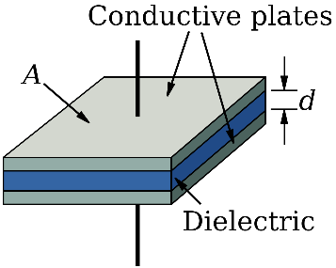
Fig. 1. Capacitor configuration. [5]

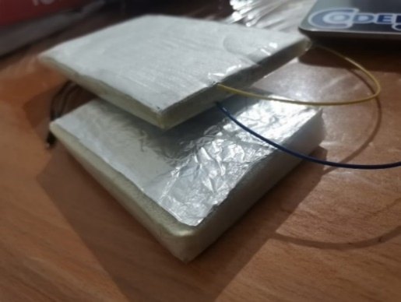
Fig. 2. Two completed sensors.

The Capacitance of the sensor is given by the following equation.

C - Capacitance
$ε_{r}$ - Relative Permittivity of the dielectric
$ε_{0}$ - Permittivity of vacuum
A - Surface area of the capacitor
d - Distance between parallel plates

$C= \frac{ε_{r}ε_{0}A}{d}$ (1)

Distance between plates when a force of F Newtons is applied is given by the following equation. Here, the stiffness(k) of the sponge is assumed to be constant.

F - Force applied
$d_{0}$ - Initial distance between parallel plates
k - Stiffness of dielectric material

$d=d_{0}-\frac{F}{k}$ (2)

Therefore,
$C= \frac{ε_{0}A}{d_{0}-\frac{F}{k}}$ (3)

and the force is theoretically given by,
$F=k\left(d_{0}- \frac{ε_{0}A}{C}\right)$ (4)

Circuit Diagram and Calibration

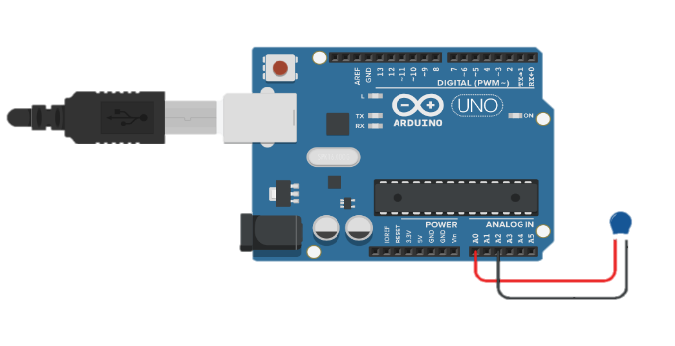
Fig. 3. Circuit configuration.

Since the capacitance is small, measuring it using a method with higher discrimination was important. Thus, a method using the internal resistances of the Arduino UNO microcontroller was used [6]. Figure 5 and 6 shows the results obtained using this method.

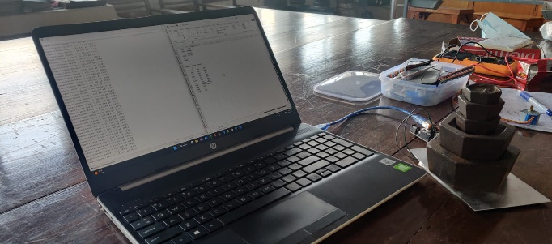
Fig. 4. Sensor calibration configuration.

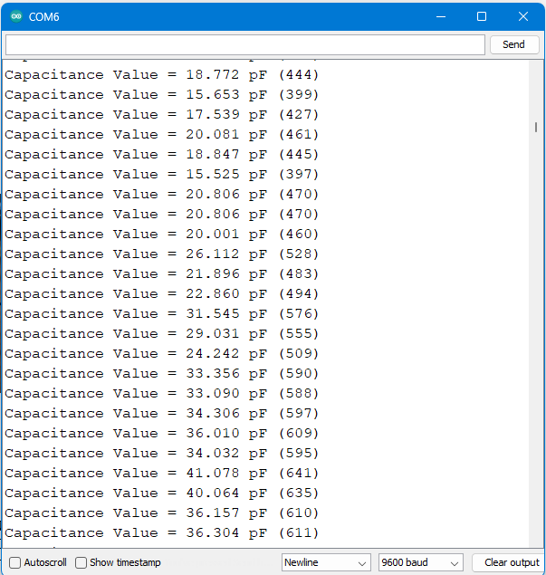
Fig. 5. Capacitance value readings.

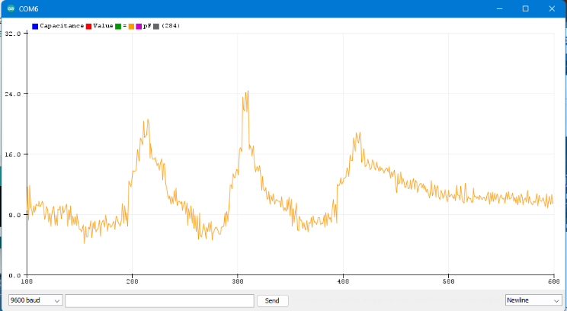
Fig. 6. Variation of capacitance against different forces.

Sensor Optimization

To regulate the point forces among the sensor, two rigid plates can be used above and below two plates. Also, the sensitivity can be increased using parallel capacitor configuration.

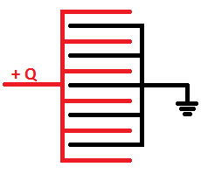
Fig. 7. Parallel capacitor configuration. [7]

Statistical Analysis
For each input, five sample measurements were taken. Averages and Standard deviations are calculated according to the readings in Table II.

σ  xi  𝑥̅  n | − Standard deviation  − Voltage reading  − Average  − No. of readings

Average = $\frac{1}{n}\sum_{i=1}^{n}{x_{i}}$ (4)

Standard deviation (σ) = $\sqrt{\frac{\sum_{i=1}^{n}{{(x_{i}-\overline{x})}^{2}}}{n-1}}$ (5)

- AVERAGES AND STANDARD DEVIATIONS
Force applied / (N) | Average output Arduino analog reading | Standard deviation
0 | 335.6 | 4.51
5 | 355.2 | 9.20
10 | 363.0 | 10.84
15 | 373.8 | 9.96
20 | 391.4 | 8.44
25 | 422.0 | 17.99
30 | 443.4 | 18.47
35 | 476.6 | 16.49
40 | 501.8 | 11.34
45 | 525.8 | 10.31
50 | 542.6 | 3.71

Results

- VARIATION OF THE ANALOG OUTPUT OF THE ARDUINO BOARD VS LOAD.

Weight | Set 01 | Set 02 | Set 03 | Set 04 | Set 05 | Avg
0 | 335 | 328 | 338 | 339 | 338 | 335.6
500 | 359 | 339 | 358 | 358 | 362 | 355.2
1000 | 371 | 344 | 368 | 365 | 367 | 363
1500 | 384 | 358 | 375 | 372 | 380 | 373.8
2000 | 398 | 377 | 393 | 392 | 397 | 391.4
2500 | 440 | 394 | 418 | 423 | 435 | 422
3000 | 462 | 416 | 439 | 441 | 459 | 443.4
3500 | 488 | 456 | 470 | 471 | 498 | 476.6
4000 | 509 | 485 | 500 | 500 | 515 | 501.8
4500 | 532 | 508 | 530 | 526 | 533 | 525.8
5000 | 546 | 537 | 542 | 542 | 546 | 542.6

Fig. 8. Variation of Analog signal of the Arduino Board
for Each Trial vs Load

Fig. 9. Variation of Average Output Analog Signal vs Load

Discussion

Difficulties

Method selection: In the previous report, there were five possible methods to measure the grip force. In four out of those five methods, the sensor has a higher complexity and contains expensive components. Then, the method of using capacitors as force measuring sensors is used since it has some major advantages at low cost.

Finding a way to measure the grip force by capacitors: Initially, many research papers, science articles, and journals are used as a reference to obtain a proper idea of the variation of the capacitance of a given capacitor under a force. With the help of these resources, a capacitor was designed on our own to measure the grip force. The primary operations of this sensor are described above.

Designing the sensor circuit: The basic sensor module does not contain any Arduino or any other microcontroller. But we used Arduino in the calibration circuit as the measured capacitance change is very small that is not sensitive to a multimeter. The calibration circuit only contains the sensor module connected to an Arduino, which measures the capacitance using an analog signal [5]. However, when using the sensor module, it should be connected to an external circuit where it can measure the capacitance since the sensor is passive.

Accessibility to the components: Designing the capacitor, a material with high permittivity and a material with constant stiffness is required. Due to its unavailability in access, material that barely fits our requirements is used.

Troubleshooting: The output signal is measured using an Arduino serial plotter. Also, a multimeter is used to check components one by one connection as there were any mistakes in the circuit.

Strengths

Size and Weight: The sensor module setup size and weight are very small. Therefore, the user can easily handle it. As the weight is small the robot arm will be able to move without any extra effort when the sensor is installed.

Installation: No need of any knowledge about the sensor, to install it.

Linearity: The output signal almost has a linear relationship with the given input.

Customizable: The sensor module can be customized as per the requirement. Therefore, this can be customized to be fixed to any robot arm.

Weaknesses

Range: The sensor will not indicate a reading for a given force that is less than 5N and higher than 50N. But the range can be increased by increasing the thickness of the material used in between Aluminium foils.

Hysteresis: The sensor will not give the same reading when loading and unloading due to the non-ideal behavior of the elasticity of the dielectric material. However, this can be reduced by introducing a spring between Aluminium foils.

Resolution: The resolution of the sensor is low because it only indicates a 5N change of force. But by using a thicker elastic material with a constant stiffness, resolution can be increased.

Comparison
This sensor has high accuracy, an easy installation setup, and a user-friendly operating system compared to other sensors. Also, it can be easily upgraded by changing the material used in between the Aluminum foils. Since the input vs output graph is almost linear, applied grip force can be easily measured.

Conclusion

A robotic grip force sensor is an electronic device that measures, how hard an object is held by a robot arm. This sensor uses the change in the capacitance of the sensor module to measure the applied force.

A successful development of this simple and effective module would be useful in robotics of any scale. This sensor only measures the grip force applied to robot arms. However, we are planning to design an automatic robot arm that changes the way it holds a given object according to its surface.

The main purpose behind this project is to learn about how the real-time application works, how to communicate various electronic devices and their outputs, how to combine them, and finally by completion of this project our ability as an engineer has boosted.

Acknowledgment (Heading 5)
A special thanks to Dr. Ruwan Ranaweera and Dr. Nalin Harischandra for dedicating their valuable time to this project, and thank you for all the heeps of suggestions you gave us. Also, would like to thank all the seniors and our batchmates who gave huge support to complete this project in the best way possible. Lastly, huge thanks to all of those who even helped us with a word. Although any mistakes or errors are our own and should not tarnish the reputations of these esteemed persons.

References

- Nachazel, T. (2022) What is a strain gauge and how does it work?, Michigan Scientific Corporation. Available at: https://www.michsci.com/what-is-a-strain-gauge/ (Accessed: February 19, 2023).
- Team, L. (2022) Piezoelectric transducer: Types, advantages, diagram, linquip. Available at: https://www.linquip.com/blog/piezoelectric-transducer/ (Accessed: February 19, 2023).
- Jaber, R., Hewson, D.J. and Duchêne, J. (2012) “Design and validation of the grip-ball for measurement of hand grip strength,” Medical Engineering & Physics, 34(9), pp. 1356–1361. Available at: https://doi.org/10.1016/j.medengphy.2012.07.001.
- ES Systems (2021) Capacitive & piezoresistive pressure sensors - differences, ES Systems. Available at: https://esenssys.com/capacitive-piezoresistive-pressure-sensors-differences/#:~:text=In%20piezoresistive%20sensors%2C%20four%20resistors (Accessed: February 19, 2023).
- Wikimedia.org. (2022). [online] Available at: https://upload.wikimedia.org/wikipedia/commons/3/35/Parallel_plate_capacitor.svg [Accessed 19 Feb. 2023].
- Campbell, S. (2021) How to make an Arduino capacitance meter, Circuit Basics. Available at: https://www.circuitbasics.com/how-to-make-an-arduino-capacitance-meter/ (Accessed: February 19, 2023).
- pani. “Parallel Plate Capacitor.” Electronics Tutorials, 21 Oct. 2014, electronicspani.com/parallel-plate-capacitor/. Accessed 19 Feb. 2023.

